# Assignment No:3

Practical Exercise: Family Tree Parsing using Knowledge Base

## 1) Problem Statement

Implement a family tree parser using a knowledge base defined in Prolog. The family tree includes facts about family members and relationships such as parents, siblings, and grandparents. The goal is to define the knowledge base using Prolog rules and use queries to retrieve specific family relationships.

## 2) Libraries Used

Python:  
1. **PySWIP**: A Python interface to Prolog, used to execute Prolog queries and parse results.  
2. **SWI-Prolog**: The Prolog engine that processes the knowledge base and rules.

## 3) Theory

A family tree can be represented using a knowledge base with facts and rules. Facts describe the relationships between individuals (e.g., 'John is the parent of Sarah'). Rules are used to infer more complex relationships (e.g., 'X is a grandparent of Y if X is a parent of Z and Z is a parent of Y'). By querying this knowledge base, we can retrieve various relationships, such as siblings, grandparents, and parents.

## 4) Methods

1. **Defining Facts**: The family members and their relationships are represented using Prolog facts. For example, 'parent(john, sarah)' defines that John is Sarah's parent.  
2. **Defining Rules**: Relationships such as siblings, grandparents, mothers, and fathers are represented using Prolog rules. For instance, the rule 'sibling(X, Y) :- parent(P, X), parent(P, Y), X \= Y' defines that X and Y are siblings if they share the same parent.  
3. **Querying the Knowledge Base**: Prolog queries are used to retrieve relationships from the knowledge base. For example, the query 'sibling(sarah, X)' retrieves all of Sarah's siblings.

## 5) Advantages and Disadvantages

- **Advantages**: The use of a knowledge base allows for the efficient representation of complex relationships. Prolog's declarative nature makes it easy to define and query relationships using logical rules.  
- **Disadvantages**: Setting up the knowledge base requires careful definition of facts and rules, and debugging complex queries can be challenging if the relationships are not well defined.

## 6) Diagram

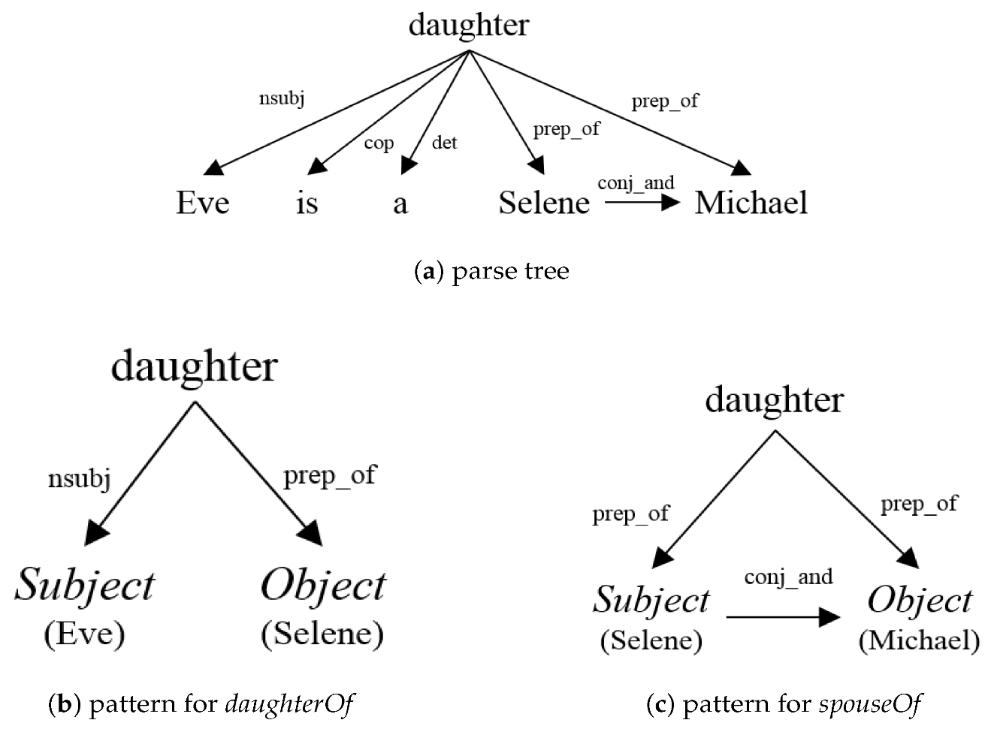**Fig 1: Enriching Knowledge Base by Parse Tree Pattern and Semantic Filter**

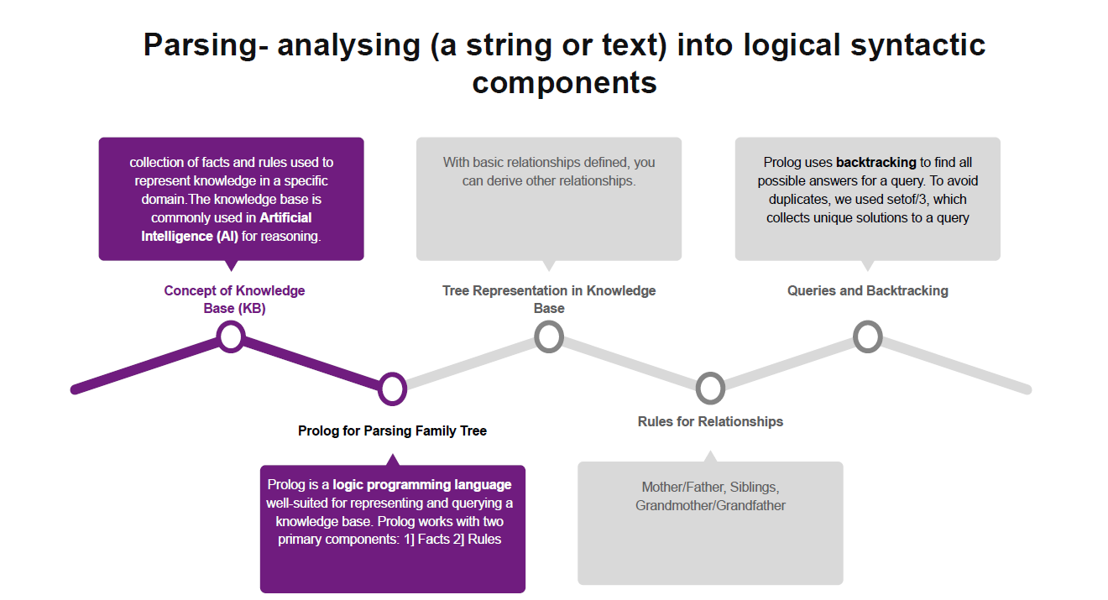

## 7) Conclusion

Family tree parsing using a knowledge base demonstrates the power of Prolog in representing relationships and solving problems using logical rules. By defining facts and rules for family relationships, we can query and infer various connections, such as siblings, grandparents, and parents, making this approach useful in domains that require relationship inference.